ECOR TUTORIAL: Technology, Society & Environment
Energy & Sustainability

The Unique Role of Exo-Somatic (outside the body) Energy in Modern Civilization.
- Without energy nothing can happen
- No factor has played a greater role in the recent explosive growth of the human enterprise than abundant cheap energy (Fossil Fuels)
- In addition, Petroleum has changed the structure of economies, the nature of technologies, the balance of geopolitics, and human quality of life.

Technology Rules: Two Great Leaps Forwards.
- Agriculture 10 millennia ago led to a 13x increase in average human population.
- The discovery and widespread use of fossil fuels, particularly petroleum, is the major physical factor behind the four-fold expansion of the human population in just the past 150 years.

Two Reasons for Moving Beyond Fire and Fossil Fuels:
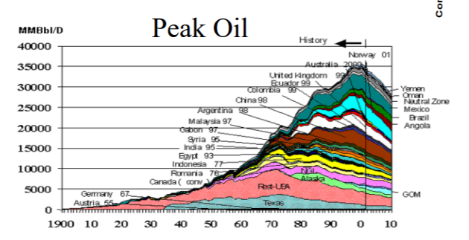
- Most people know that we may be forced to use less fossil fuel to avoid risk of serious climate change. That is what the Kyoto debate is all about.
- Fewer people are aware that we may soon have less fossil fuel to burn because the inexpensive, easily accessible stocks are being depleted.
- Peak is hard to determine if it really is there, but you can see that throughout time, it is going down.
- The risk of pushing a green market might cause a large push back in development since wealthy people (who got their wealth from oil) will lose money. It is easier for them to just not believe you.
- Non-renewable energy takes up 89% of energy we use.
- Renewable energy takes up 11% of energy we use.
- Global CO₂ Emissions have sky rocketed in the last 70 years

Canada’s GDP, Energy Consumption and CO₂ Emissions
- In 1973 A deliberate reduction in oil deliveries known as the OPEC oil embargo occurred.
- More efficient energy use as result of energy crisis
Two Reasons for Moving Beyond Fire and Fossil Fuels:

